Test Result (Kaii)

**NUnit Test**

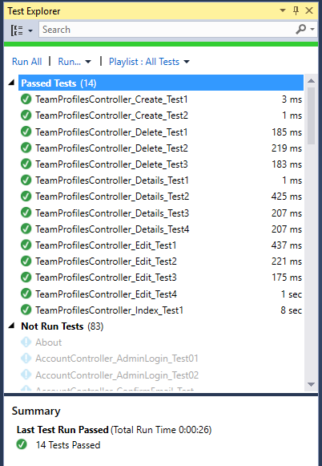

**Acceptance Tests**

User story 1: Refine the success story list page (client view)

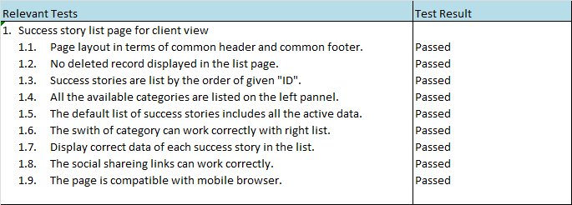

User story 2: Dynamic team profile page (client view).

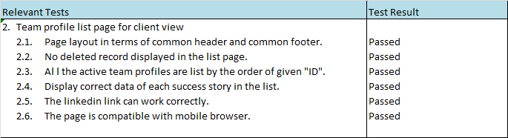

User story 3: Team profile admin functions

